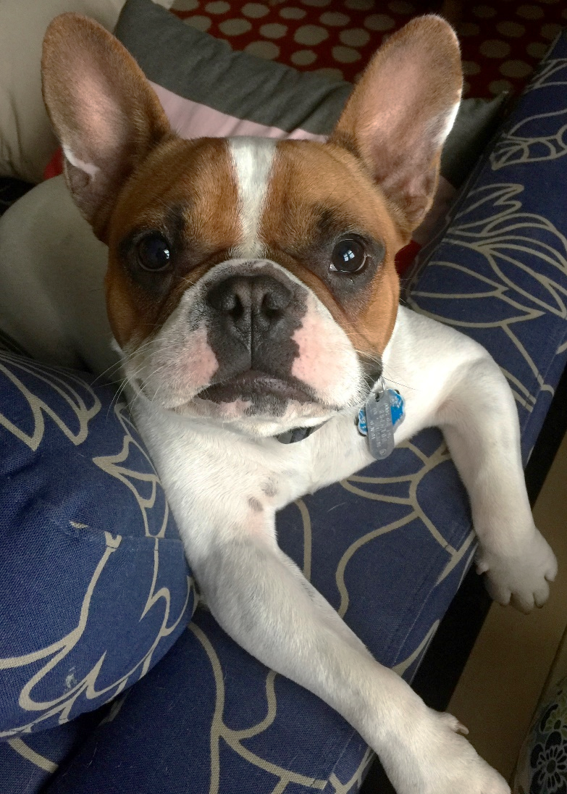
I DON’T ALWAYS PRINT MAKE, BUT WHEN I DO I GELLI PRINT!

PRINTMAKING REQUIREMENTS:
- Minimum of 1-2 good, clean, neat layered prints
- 1 image transfer print (magazine)
- 1 print with sharpie designs
- 1 tape transfer
- 1 print on alternative paper
THINGS TO REMEMBER:
- This paint can stain! Be careful!
- Names go on the back of your prints in pencil!
- Less ink is better than too much!
- MAGAZINE TRANSFERS: Wet printing technique
  - Light Color (or Print) FIRST!
  - Then Dark Color and Magazine NEXT
    - You must PRINT WHEN INK IS WET!!!
    - Make sure to line up your prints with box on your placemat
- TAPE TRANSFERS: DRY printing technique
  - Whatever you’d like to show up on the tape needs to be on top of the printing plate!

IS TODAY OUR LAST DAY TO PRINT?

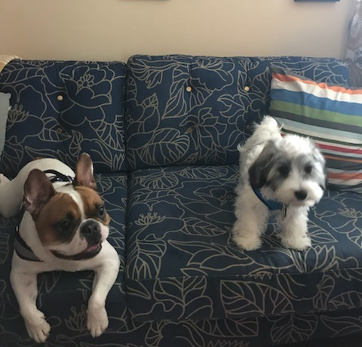

YES, YES IT IS! TAKE OUT YOUR TABLE FOLDER!

FINISHED WITH ALL YOUR PRINTS AND THEY ARE AMAZING?! WORK ON A FEATHER!
PRINTMAKING REQUIREMENTS:
- Minimum of 1-2 good, clean, neat layered prints
- 1 image transfer print (magazine)
- 1 print with sharpie designs
- 1 tape transfer
- 1 print on alternative paper
THINGS TO REMEMBER:
- This paint can stain! Be careful!
- Names go on the back of your prints in pencil!
- Less ink is better than too much!
- MAGAZINE TRANSFERS: Wet printing technique
  - Light Color (or Print) FIRST!
  - Then Dark Color and Magazine NEXT
    - You must PRINT WHEN INK IS WET!!!
    - Make sure to line up your prints with box on your placemat
- TAPE TRANSFERS: DRY printing technique
  - Whatever you’d like to show up on the tape needs to be on top of the printing plate!

